# Optional Fields in Elasticsearch

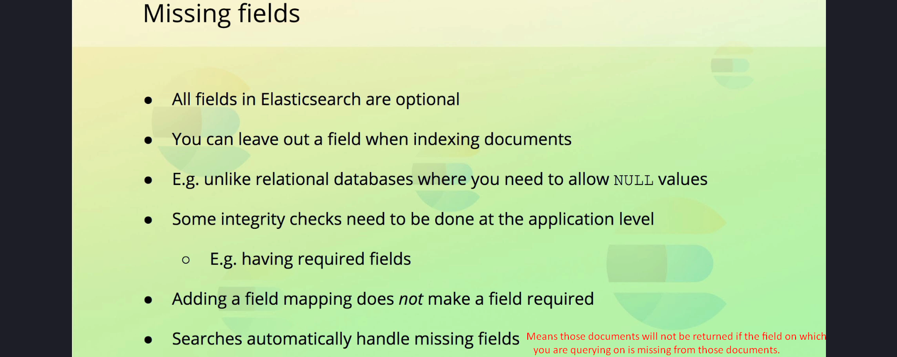

## 1. Introduction

In Elasticsearch, fields are optional by default. This means that fields can have zero or more values, and documents can be indexed without including specific fields, even if a mapping exists for those fields.

This behavior differs from relational databases, where fields need to explicitly allow NULL values. In Elasticsearch, you are free to omit fields entirely when indexing documents.

## 2. Example of Missing Fields

Consider a scenario where a 'created_at' field was added to the mapping for a 'reviews' index after some documents had already been indexed. Documents indexed before this addition will not contain the 'created_at' field.

Here’s an example of a document missing the 'created_at' field:  
{  
 "_source": {  
 "rating": 4.5,  
 "content": "Great product!",  
 "product_id": 12345,  
 "author": {  
 "first_name": "John",  
 "last_name": "Doe",  
 "email": "john.doe@example.com"  
 }  
 }  
}

## 3. Handling Optional Fields

Elasticsearch does not enforce the inclusion of fields in documents, even if a mapping exists for them. As a result, field mappings do not make fields required.

**If you need certain fields to always be present, this should be enforced at the application level**. For instance, you can validate documents before indexing them to ensure required fields are included.

Key points to note:  
- Elasticsearch validates field values against their mappings but does not reject documents with missing fields.  
- Field presence and integrity checks should be handled outside Elasticsearch, typically at the application level.

## 4. Searching with Optional Fields

When performing search queries, Elasticsearch only considers documents that contain a value for the specified field. You do not need to handle missing fields explicitly in your queries. For example, a query searching for documents with a specific 'created_at' value will only return documents where this field is present.

GET /reviews/_search  
{  
 "query": {  
 "range": {  
 "created_at": {  
 "gte": "2025-01-01T00:00:00Z"  
 }  
 }  
 }  
}

## 5. Summary

1. Fields in Elasticsearch are optional by default, allowing documents to be indexed without including all fields.  
2. Field mappings do not enforce field presence; this must be managed at the application level.  
3. Elasticsearch validates field values but does not reject documents with missing fields.  
4. Search queries automatically exclude documents missing the specified fields, simplifying query logic.